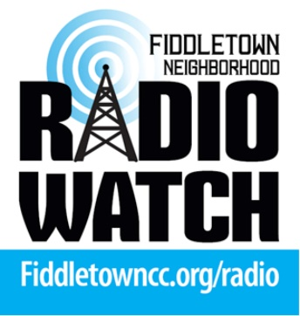

FNRW Committee Zoom Meeting
Wednesday, October 25, 2023 @ 7:45 PM
AGENDA

- Welcome.

- Approve Minutes of September 13, 2023 meeting.

- Treasurer’s Report.

- Old Business.
- Giving Tuesday Nov 28th @ Drexell Hall. - Bob
- CR repeater servicing Saturday October, 14 – Steve/Kent
- Fundraising and Grants. - Sue
- Net control sign-ups. - Bob

- New Business.
- Equipment needed.
- Power supply for CR repeater – Steve & Kent
- Install West Mountain controller. Kent
- Two more 12v batteries.
- Install 2 solar panels – OK with Lisa – need brackets fabricated. - Kent
- Fundraising ideas.
- FCC Thanksgiving potluck – share table with FCC.
- Need volunteer from FNRW to answer questions. Inform audience on the benefit of having a group like FNRW in our community.
- Donations to FNRW made by checks can be postdated for 11/28/23 for matching ACF funds.
- Giving Tuesday presence at Drexel Hall ACF – table skirt / brochures / FNRW sign banner.
- Annual FCC membership form to have a checkbox to donate $20 to FNRW.

- Amador Community Foundation as our 501.(3)(c).
- Pros
- Will do all administrative work related to donation funding – Raffle events – ABC alcohol licensing – Bookkeeping – other things.
- Cons
- Seven percent charge per every dollar we take in.
- Yearly liability insurance charge.
- Other yearly costs.
- No meeting hall available to us.
- No zoom account usage.
7. Need community center library to hold training on how to host a Net Control session. A few members have requested training.

8. Adjournment.

FNRW Board Minutes
October 25, 2023

In Attendance:
Bob Kleinbrahm, Chair
Kate Dougherty, Secretary
Kent Oster, Technical Expert
Steve Allred, Technical Expert
Sue Wilson, Member at Large
Absent:
Deidre Mueller, Acting Secretary

- TOPIC: Review Minutes from September 13, 2023 Meeting
Discussion: Reviewed, no changes requested
Conclusion: Motion to approve and seconded
Action: Approve Minutes
- TOPIC: Financial Report
Discussion: Reviewed Financial Report
Conclusion: All Line Items Accounted for.
Action: Approve Financial Report
- Old Business:
- Giving Tuesday, Nov 28, Drexel Hall
>>>>>Sue Wilson will check if she can staff event.
- Cobble Ridge Repeater Servicing October 14
>>>>> New Antenna has improved reception.
- Fundraising and Grants
>>>>>Sue will continue to explore grant resources as priorities established.
- Net control sign-ups
>>>>One volunteer has signed up>Bob Will Train

3. New Business
- Equipment Needs
>>>Articulated in Agenda; Sue, Bob, Kent to document priorities
- Fundraising Ideas
>>>>. November 11, Thanksgiving Potluck at FCC, Bob will have donations and promotion of GMRS Network, need volunteer for questions. Checks can be postdated to Nov 28 to get Amador Foundation Matching Funds. Form Will include FNRW in Membership FCC Renewal
>>>>>>November 28, Giving Tuesday at Drexel Hall, Sue Wilson may staff.
- TOPIC: Amador Community Foundation as our 501.(3)c
Discussion: Reviewed pros and cons as articulated on agenda.
Conclusion: We have a sponsorship agreement with FCC at 5% which takes care of all of our administrative needs.
Action: We will maintain sponsorship agreement with FCC at this time.
- TOPIC: Training for Net Control
Discussion: Use library to train for Net Control.
Conclusion: Hopefully will locate more volunteers for Net Control role
Action: We will continue to recruit and look to January 2024 for training.

