January 18, 2023

FNRW Zoom Meeting Minutes
Began Meeting at: 7:45 pm. Ajorned 8:41

In attendance:
Bob Kleinbrahm, Chair
Kate Dougherty, Secretary
Sue Wilson, At Large Member
Kent Oster, At Large Member
Steve Allred, At Large Member
Deidre Muller, FCC Liaison

Absent:
Barb Reilly, Treasurer

TOPIC 1: Minutes from September 14, 2022 Meeting
DISCUSSION: Minutes distributed electronically and reviewed.
CONCLUSION: Motion to Approve, and seconded with no objections or changes
ACTION: Approve Minutes for September 14, 2022 Meeting.

TOPIC 2: Appropriate Radio Use
DISCUSSION: Recent situation with burglary in progress on Tyler Road. Three suspects, all who fled on foot. Is that an appropriate to report on GMRS network? Some said yes. Others say no.
Conclusion: We need guidance from the Sheriff’s office.
ACTION: Sue Wilson to ask Sheriff this question.

Page 2 of 3, FNRW Minutes, January 18, 2023

TOPIC 3: Year End Review
DISCUSSION: Successes include: FNRW topics in Fiddletown Newsletter; Created Banners, Built Inventory of
radio supplies, had a booth at both Smoke Chasers and Fiddler’s Jam, Newspaper Article in Ledger. Collaborated with neighboring communities to build their own network. Total Membership of the FNRW Network is 61. Fundraiser allowed us to erect Cobble Ridge Repeater.
CONCLUSION: We will continue to contribute to the Newsletter, and attend fairs and events.
ACTION: Kate will reach out to Sector Leaders for FireWise Communities, to encourage all of the households in their FireWise Community to consider buying GMRS equipment.
Kent to reach out to Susie Jones to order a small batch of T-Shirts with FRNW logo.

TOPIC 4: Radio Supplies Inventory
DISCUSSION: Attached agenda for equipment on hand. During net control Bob has noticed some member’s batteries are failing.
CONCLUSION: All members should have functional equipment.
ACTION: Bob is letting members know they may need a new battery if he hears a problem. We will need more spare batteries
TOPIC 5. Fiscal Sponsorship by Fiddletown Community Center, non-for-profit status.
DISCUSSION: Deidre Muller explained we need to formalize our relationship with FCC who is acting as our fiduciary sponsor. Reporting requirements include sending, financial report, minutes and end of year report to FCC Board.
CONCLUION: Draft Sponsorship Agreement with FCC.

Page 3 of 3 FNRW Minutes, January 18, 2023

ACTION: Sue Wilson will customize boilerplate Sponsorship Agreement, distribute to the FNRW board, and Bob Kleinbrahm, Chairperson, to execute when finalized. Kate will continue to generate minutes and write end of year report. Barb to generate P&L statement for calendar year 2022. (See attached). The Board unanimously agreed to a 2-year term, so we are beginning 2nd year for 2023.

TOPIC 6: Cobble Ridge Repeater
DISCUSSION: Cobble Ridge needs a new repeater.
CONCLUSION: Apparently repeater has been purchased, on hand and ready to install.
ACTION: Cobble Ridge is getting an antenna upgrade to the Comet 712EFC, the same antenna used at Red Mule.

TOPIC 7: Charge Controller for Cobble Ridge
DISCUSSION: A backup for Solar is more expensive but lasts longer.
CONCLUSION: The current charge controller is on loan for Kent and needs to be replaced. Rather than ordering an exact replacement we are going to get one with solar charging capabilities. It is about $80 more than the current charger, but will not have to be replaced when we add solar panels in the future.
ACTION: Steve and Kent to purchase and install Solar Charge Controller.

TOPIC 8: Future equipment needs
DISCUSSION: Several items identified.
Conclusion: We need to evaluate costs of new equipment and future fundraising needs.
ACTION: Kent and Steve to generate list of future equipment needs and associated costs. Also, Sue, Kent and Steve will explore old and new grant sources as a means to raise funds for new equipment.

FNRW Committee Agenda
January 18, 2023 @ 7:45 PM

- General meeting to welcome everyone and begin planning for the 2023 season.

- Go over minutes from last meeting held on 9/14/22???.

- Discuss what was successful last season and what needs improving.

- General inventory of equipment in stock.

  - Radios:

  - Misc:
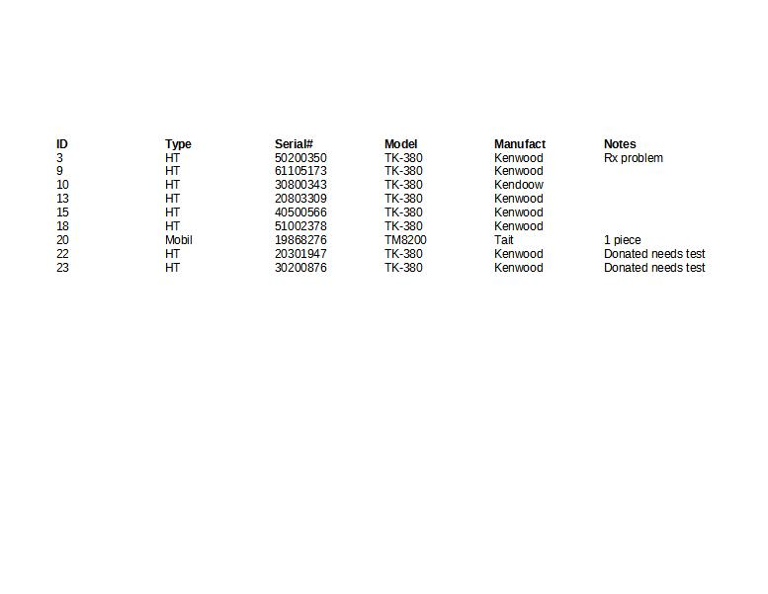
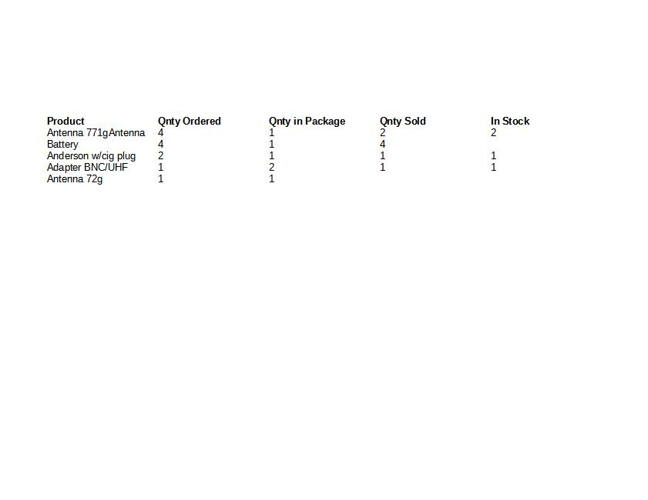
- Plans for 2023.

  - Replace antenna on Cobble Ridge with better unit. *Share image of new antenna.

  - Replace current charge controller unit on Cobble Ridge. On loan from Kent to get system up and running last year. *Share image of proposed unit and its benefits.

  - Keep extra batteries in stock to have available to users.

- P&L statement. – Current?

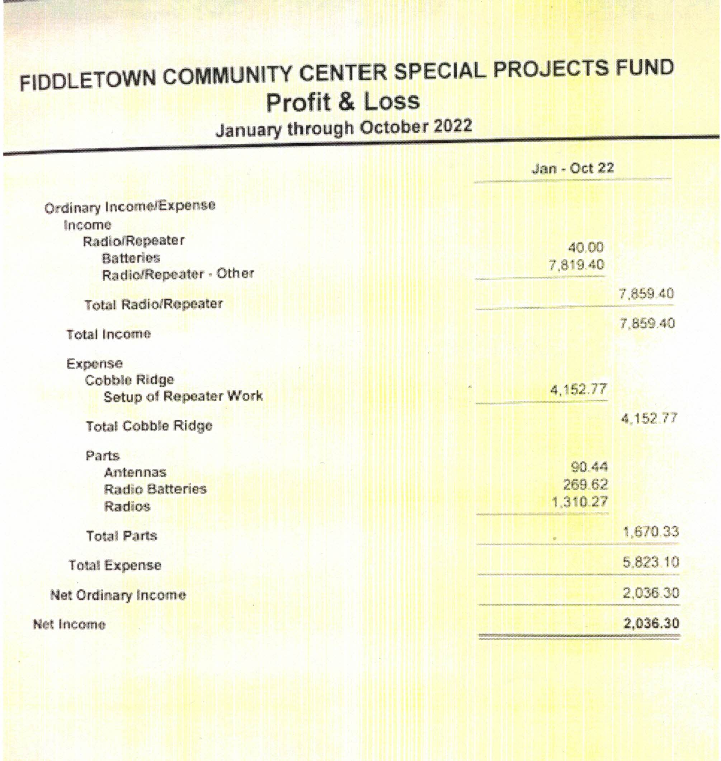

- Discuss keeping our committee member positions and/or changes.

- Adjourn.

FNRW Committee Agenda
January 18, 2023 @ 7:45 PM

- General meeting to welcome everyone and begin planning for the 2023 season.

- Go over minutes from last meeting held on 9/14/22???.

- Discuss what was successful last season and what needs improving.

- General inventory of equipment in stock.

  - Radios:

  - Misc:

- Plans for 2023.

  - Replace antenna on Cobble Ridge with better unit. *Share image of new antenna.

  - Replace current charge controller unit on Cobble Ridge. On loan from Kent to get system up and running last year. *Share image of proposed unit and its benefits.

  - Keep extra batteries in stock to have available to users.

- P&L statement. – Current?

- Discuss keeping our committee member positions and/or changes.

8. Adjourn.

